**Examination Answer Book**

**UNIVERSITY EXAMS**

|  |  |  |  |  |  |  |  |  |  |  |  |  |  |  |  |
| --- | --- | --- | --- | --- | --- | --- | --- | --- | --- | --- | --- | --- | --- | --- | --- |
| REGISTRATION NUMBER | | | | | | | | | VU-BSF-2403-0802-DAY | | | | | | |
| Title of The Program (eg BBA, BSC, BPH, BSWA) | | | | | | | | | | | | | BSF | | |
| Bachelor of Science in Software Engineering | | | | | | | | | | | | | | | |
| Department | | | | Other Depts in Faculty of Science and Technology | | | | | | | | | | | |
| Faculty | Faculty of Science and Technology | | | | | | | | | | | | | | |
| Year Of study (YrI , YrII, YrIII, or YrIV) | | | | | | | | | | | 1 | | | | |
| Module Code and Name | | | | | | | 1301 ST | | | | | | | | |
| Object Oriented Programming | | | | | | | | | | | | | | | |
| Semester | | | 2 | | | | | | | | | | | | |
| (Copy from the heading to the Examination Paper) | | | | | | | | | | | | | | | |
| Retake: | | Yes | | |  | | | No | |  | | (Tick whichever is applicable) | | | |
| Date of examination | | | | | | Fri Aug 16 2024 09:00:00 GMT+0300 (East Africa Time) | | | | | | | | | |
|  | | | | | |  | | | | | | | | | |
| **DIRECTIONS TO CANDIDATES (Turn to page ii for more instructions).** | | | | | | | | | | | | | **FOR USE BY EXAMINERS ONLY** | | |
| **Question Number** | **Internal Examiner** | **External Examiner** |
| 1. Leave margin blank. 2. Begin each answer on a fresh page. 3. Write the number of each question and theCandidate's Number at the top of each page. 4. Write the numbers of the questionswhich you have attempted, with subsections where necessary, in the spacesprovided below | | | | | | | | | | | | |
|  |  |  |
|  |  |  |
|  |  |  |
|  |  |  |
|  |  |  |
|  |  |  |
|  |  |  |
|  |  |  |
|  |  |  |
|  |  |  |
|  |  |  |
|  |  |  |
|  |  |  |
|  |  |  |
|  |  |  |
| **TOTAL** |  |  |

|  |  |  |  |  |  |  |  |  |
| --- | --- | --- | --- | --- | --- | --- | --- | --- |
| **NUMBER OF QUESTIONS** you have answered in the order in which you have written them | | | | | | | | |
|  |  |  |  |  |  |  |  |  |

**How and where should I submit my examination script?**

Every student will be required to attend their examination via [VClass Students Portal](https://vclass.ac/) E.g. you go to [www.vclass.ac](http://www.vclass.ac) and login, to your account, then on the left sidebar menu **click on Examinations**.

Under examinations you will see the following: -

1. Instructions for that particular examination with time required to finish your examination as per instructions,
2. A student will be required to download the question paper and the answer sheet provided by the university within the same module examination, or a student can be required to attempt structured questions within the system depending on how the examination was set.
3. Submission of answered questions is done,
4. Student is required to click to **consent** to show that the answered exam belongs to them.
5. **Note** that if an examination is for download, a student will be required to download the question paper and answer sheet, write their examination within the given stipulated time.
6. Required to scan and upload back the answered booklet through the same portal as per format available.
7. Examinations uploaded will directly be received by the Registry department.
8. Students here are required to use [VClass e-Learning system](https://vclass.ac)for all examinations and for any failure they can contact the Registry department for guidance.
9. No late submission will be accepted.

**Avoid any examination malpractice because this will attract severe penalties such as invalidating the exams answered script whose consequences will attract retakes.**

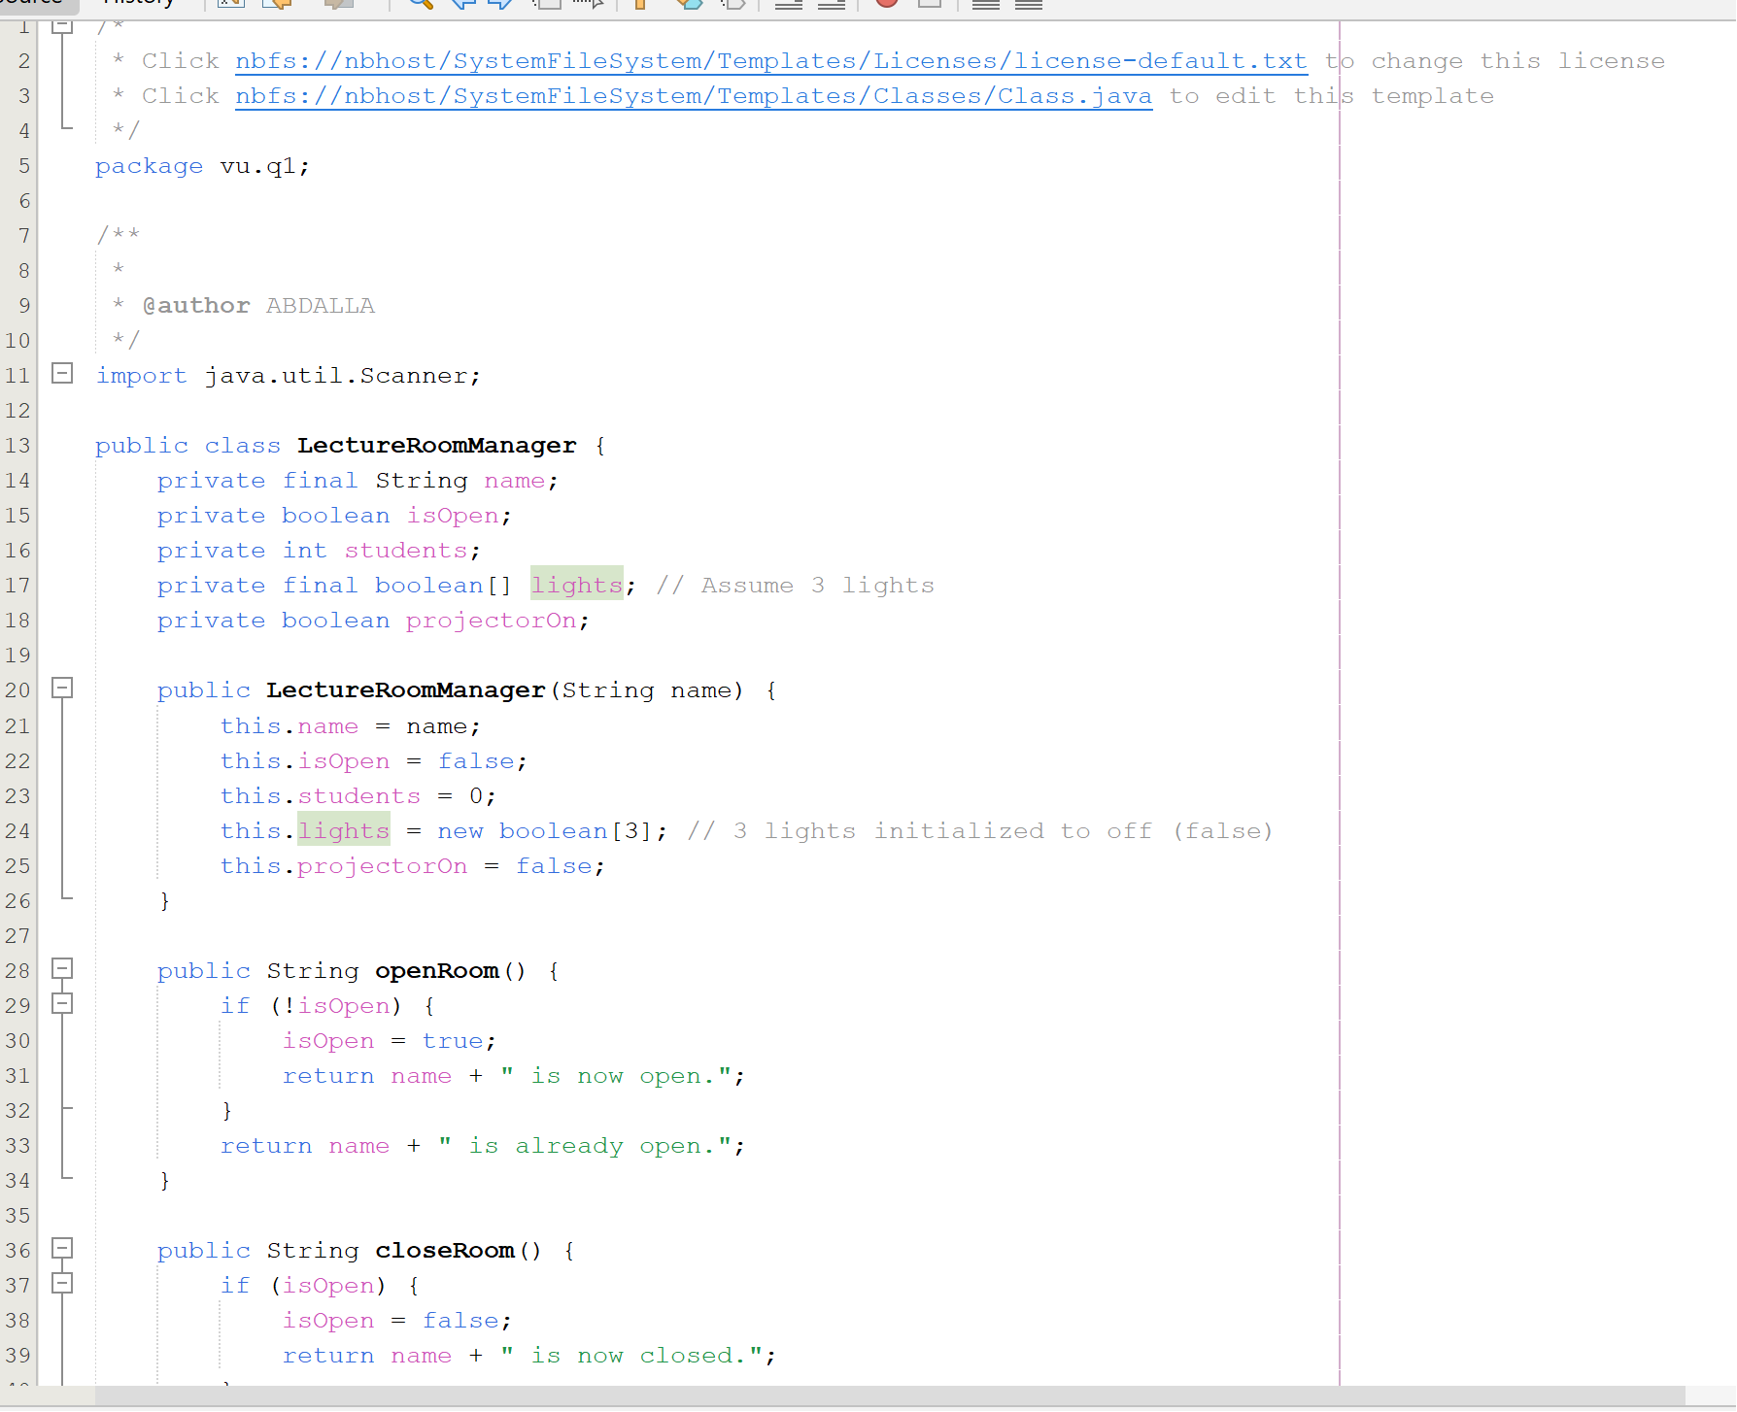

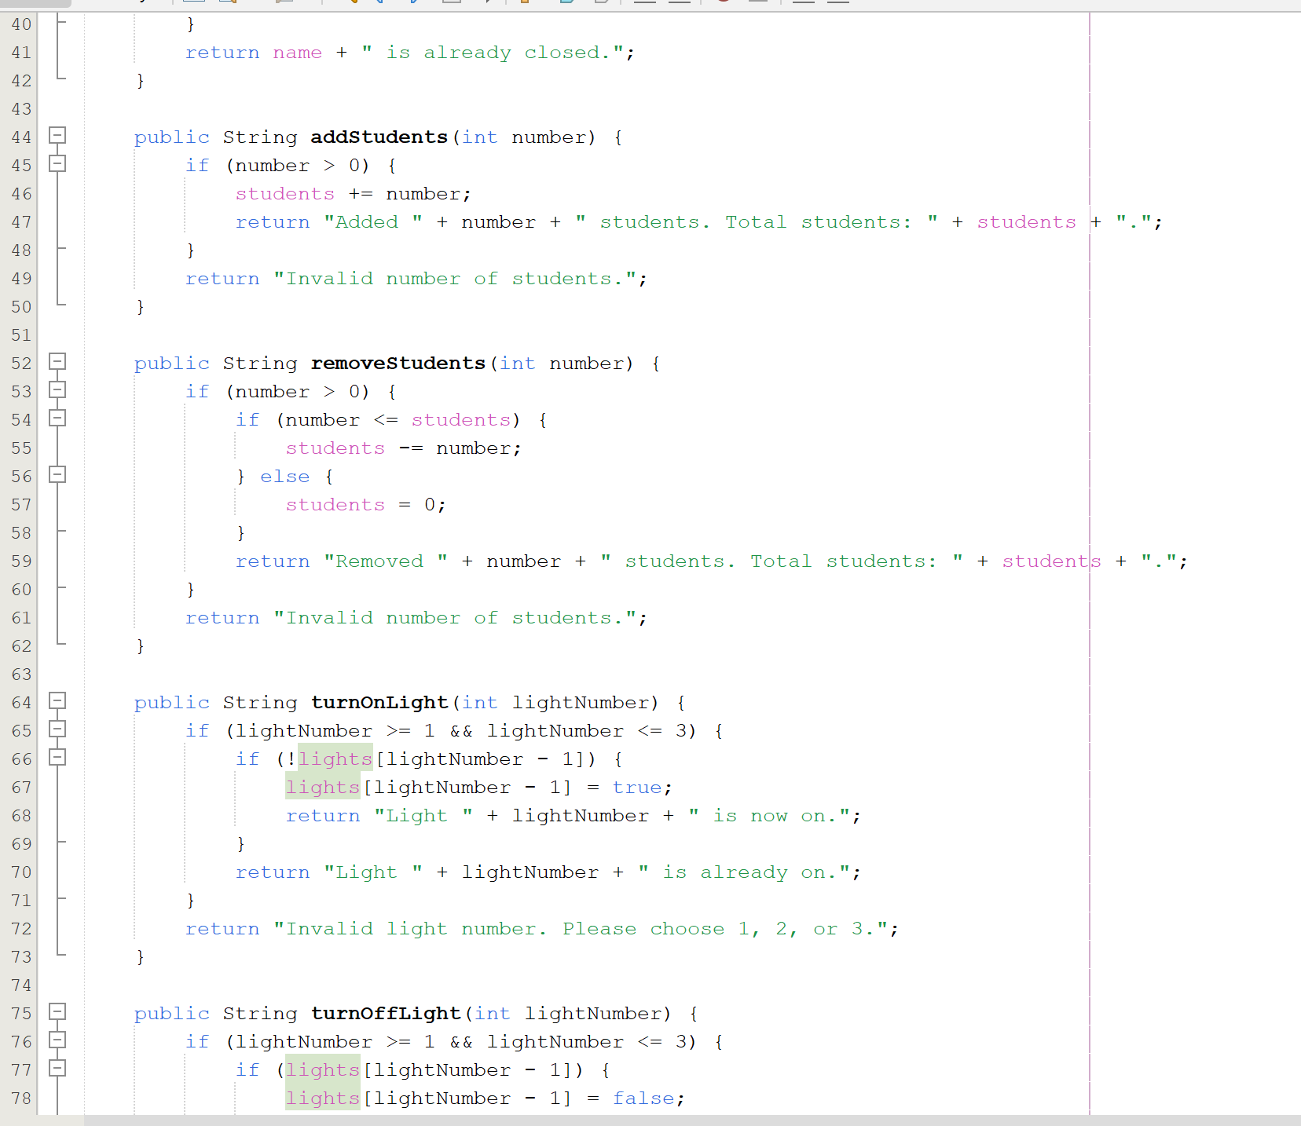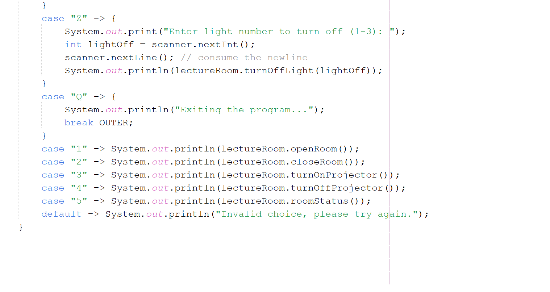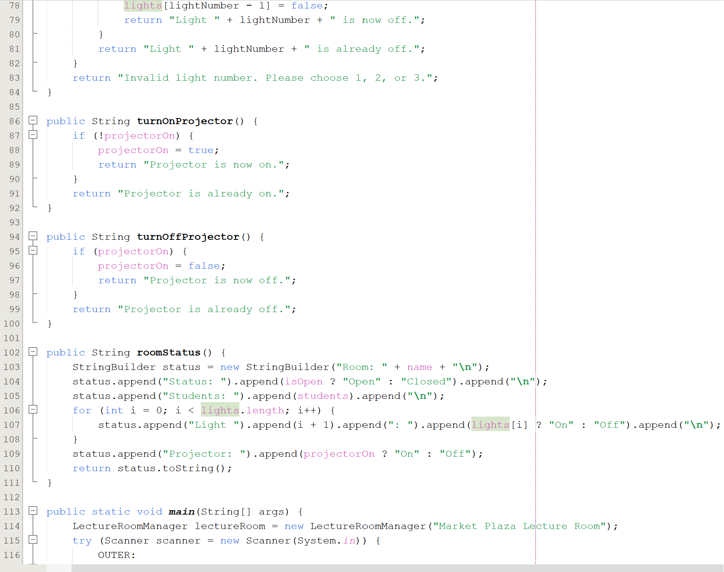

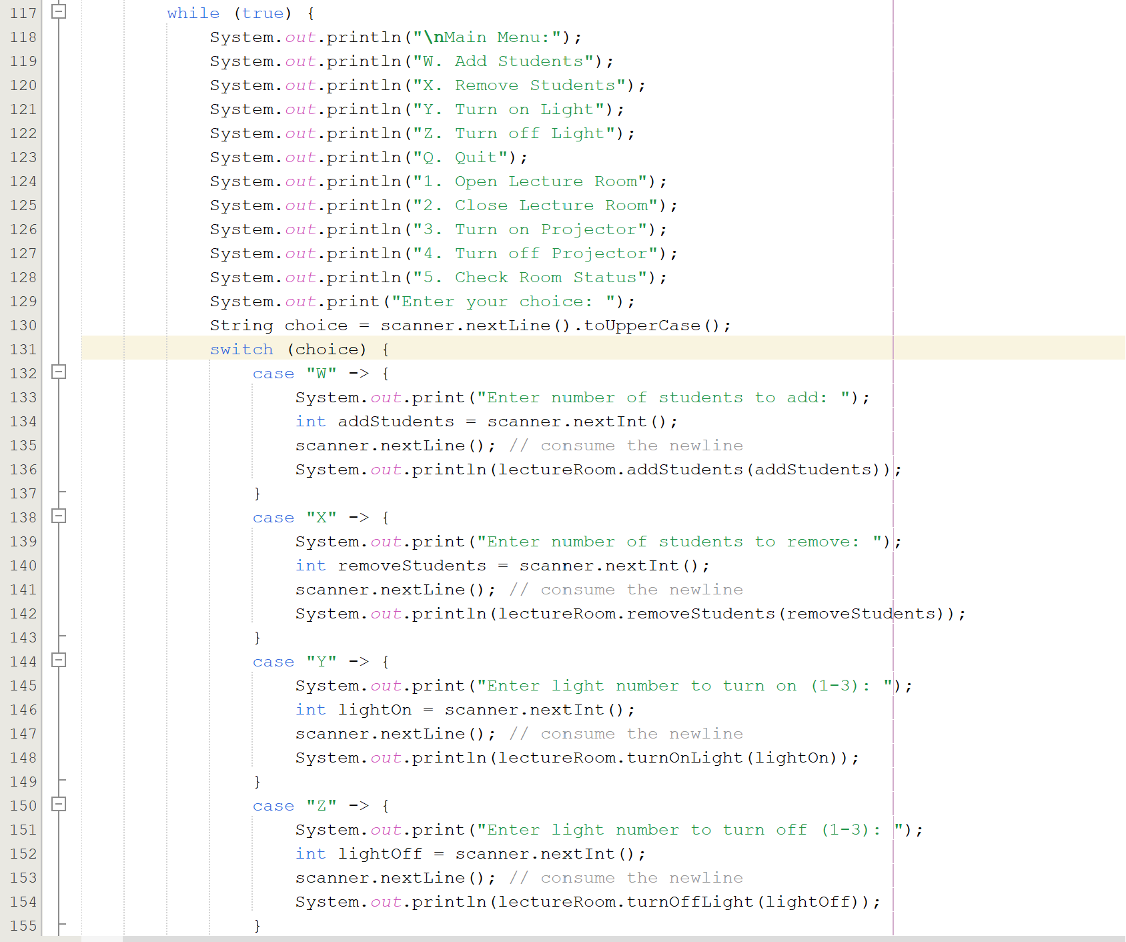

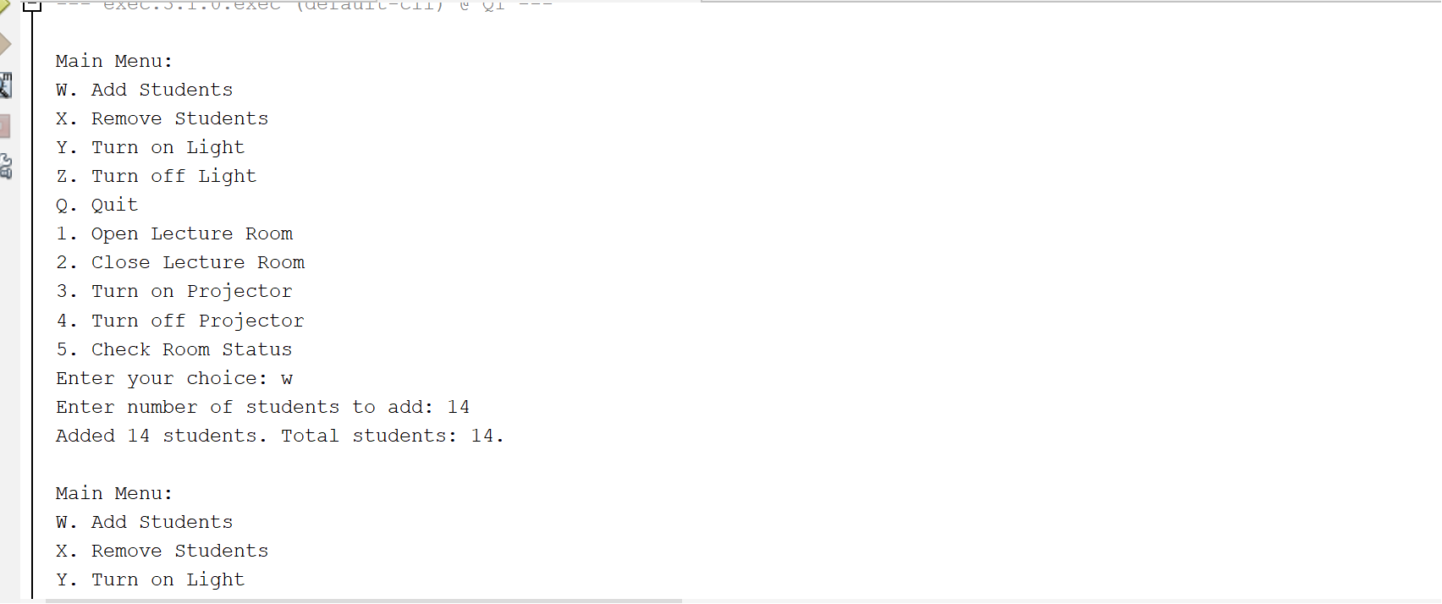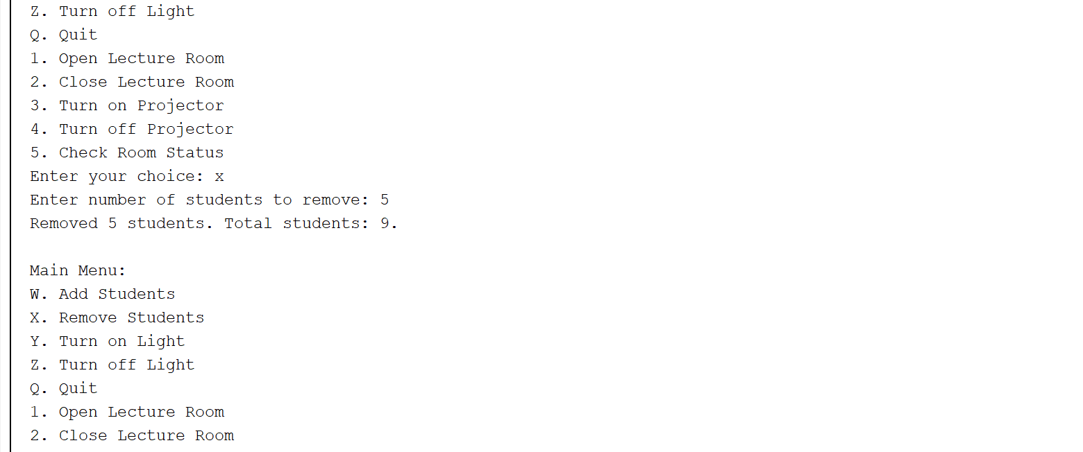

Question 2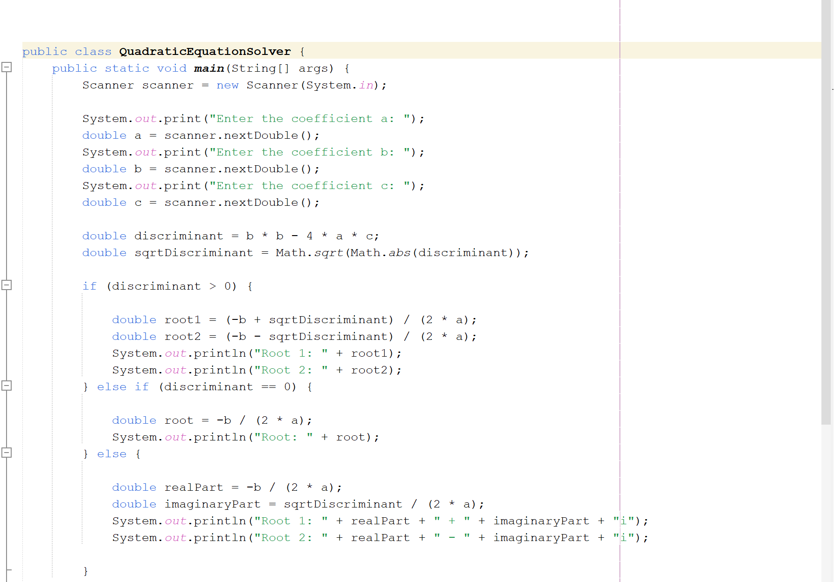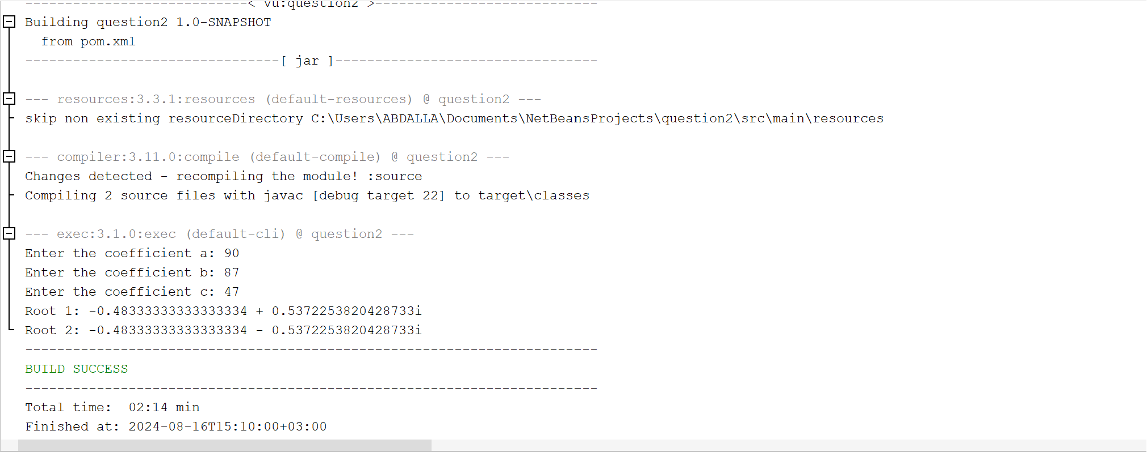

Question 3

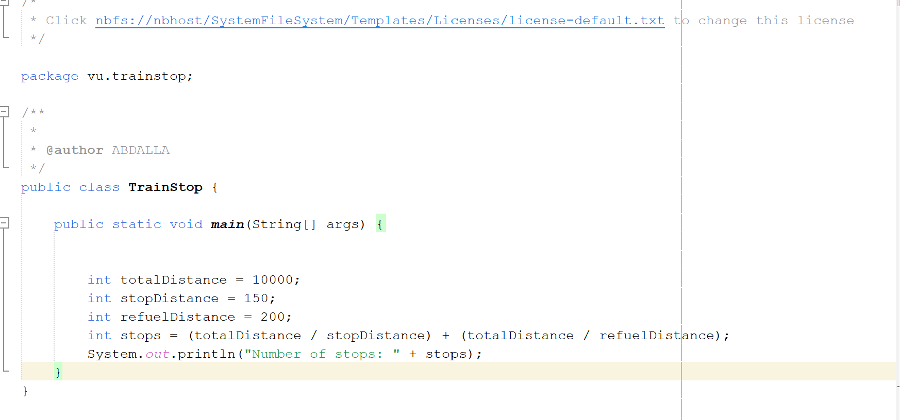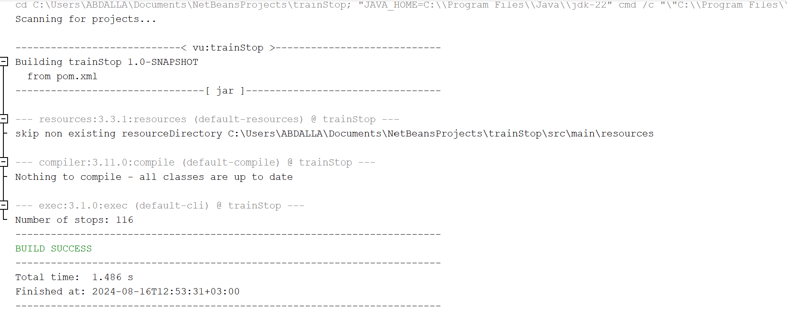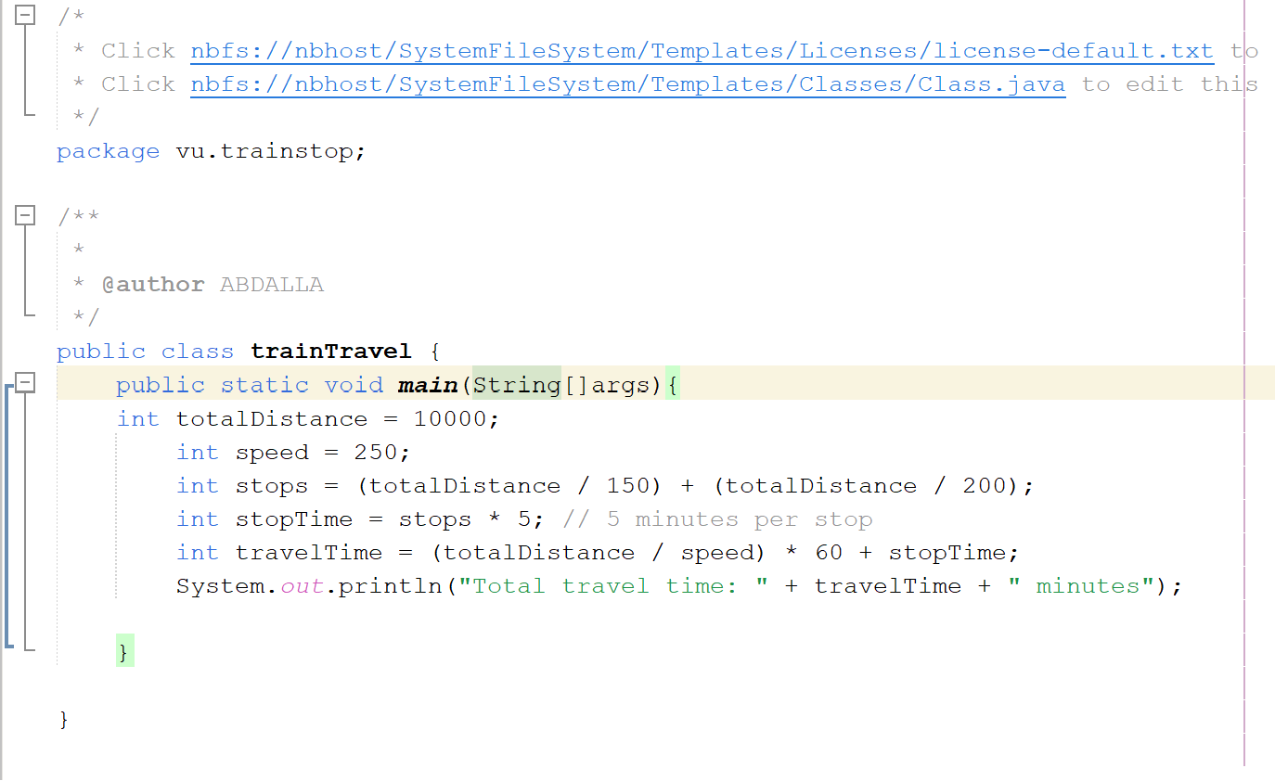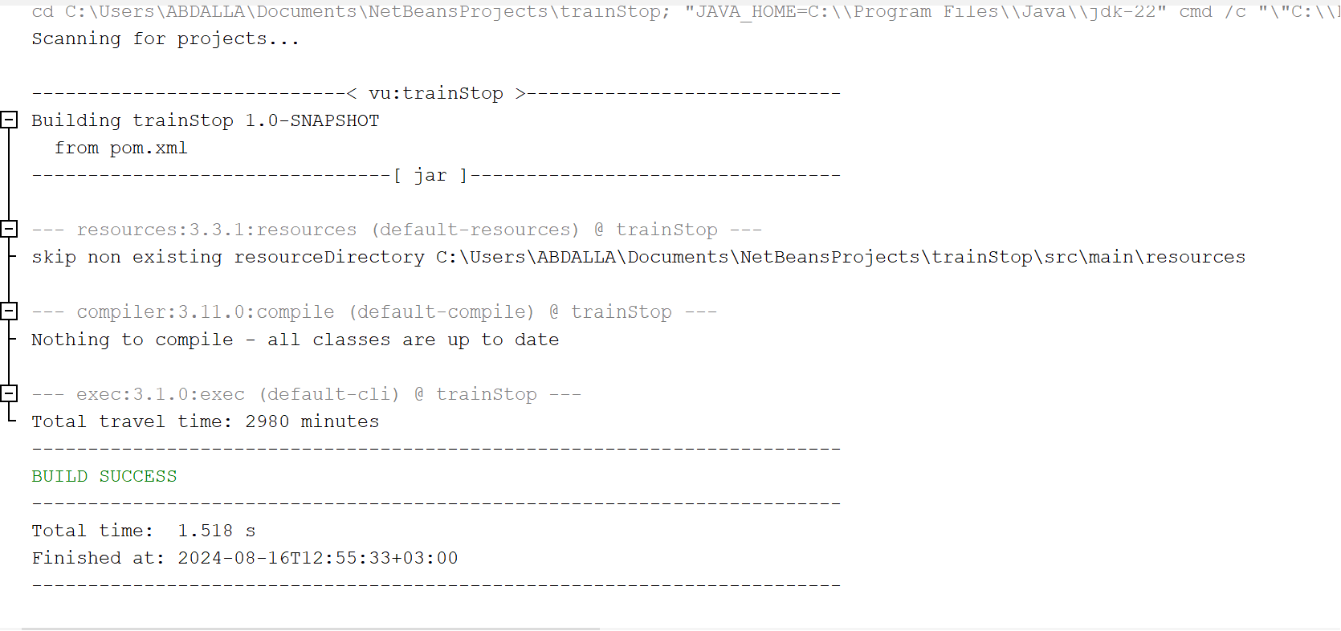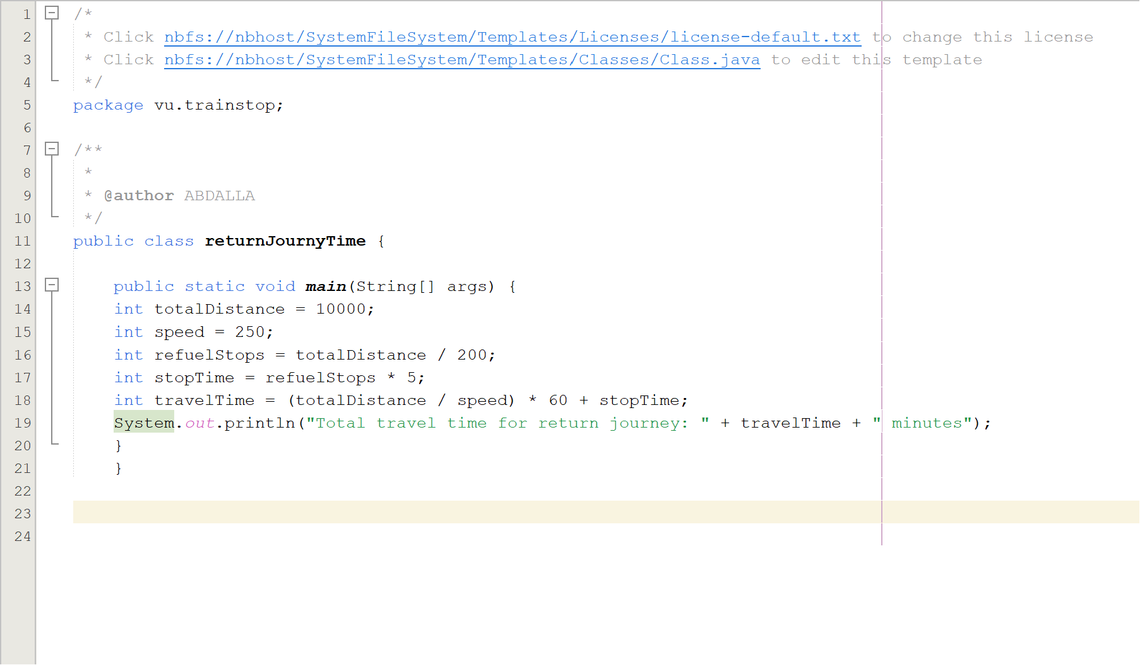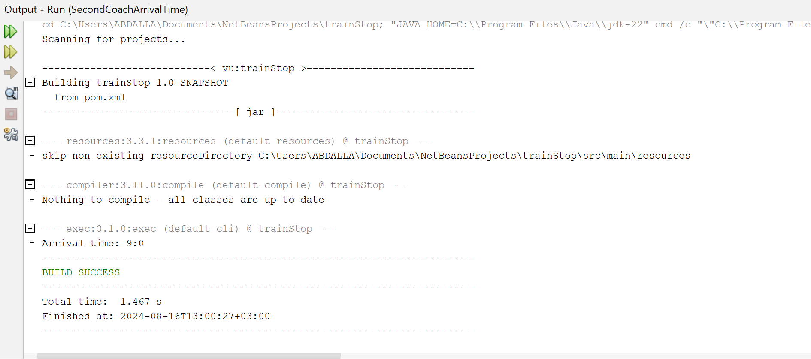

Question 4

